**Workflow Functional Document**

|  |
| --- |
| **Application :** NGERP-CENTRA |
| **WorkFlow :** Procurement To Pay |
| **WorkFlow Item Name :** Import RS-Purchase |

**Description :**

**Import RS-Purchase** used to create Purchase order automatically based on Bpartner, Product & Entity, Import RS_purchase file comes from Abbott Nutrion

**Work Flow Process:**

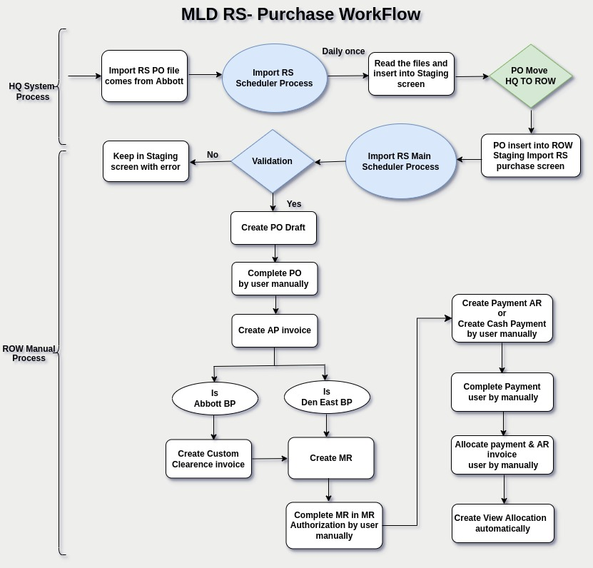

**Business Rules :**

* Import RS- Purchase file comes from Abbott nutrion companys
* The files are located in a specific path (/MLD/EDI/NGERP/WIP)
* Import Recommended Shipment scheduler read the file from specific path
* Import RS- PO file contains Abbott Bpartner, Den East Bpartner PO, P details
* Validation verify PO file

DenEast BPartner PO :  
Source_Loc='T94'

Abbott Bpartner PO :  
Order_Type='S' and Source_Loc<>'T94'

* Warehouse,product and partner code, Entity & DT validation
* Once the validation process has succeeded, it insert records in temporary table-(UM_I_RecommendedShip) Scheduler Process in HQ
* UM_I_RecommendedShip data move HQ to ROW Import RS-Purchase temporary table
* Import Recommended Shipment scheduler Main read the Import RS-Purchase

Once the validation process has succeeded, it insert records I_order table draft statius

* user complete PO by manually
* AP invoice create based on specific PO & create custom clearance invoice by user manually
* Create MR by user manually based on specific completed AP invoice, if AP invoice & custom clearance invoice not create MR cannot allow to create by user
* once create MR complete by user manually in MR authorization screen
* User create Payment – AP by manually or System allow to create AP payment for Generate payment form based completed AP invoice (serial no mandatory)
* User create/complete AP payment by manually
* User allocate payment & invoice by user manually, once allocation completed View allocation created automatically by system
* AP invoice after allocation completed paid check box ticked automatically by system
* Payment – AP allocation completed allocated check box ticked automatically by system